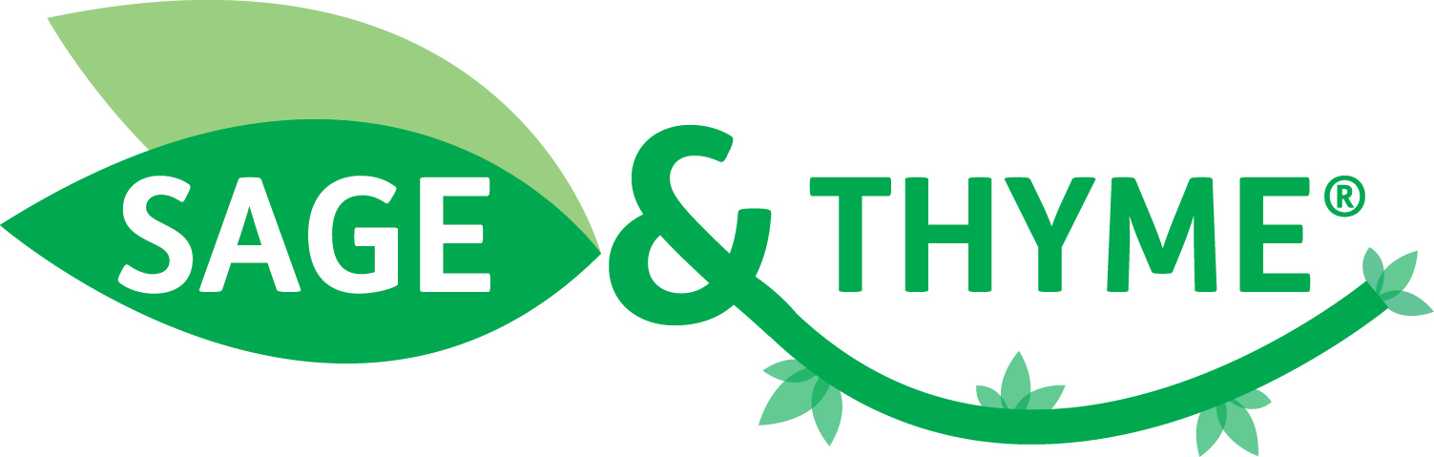 | 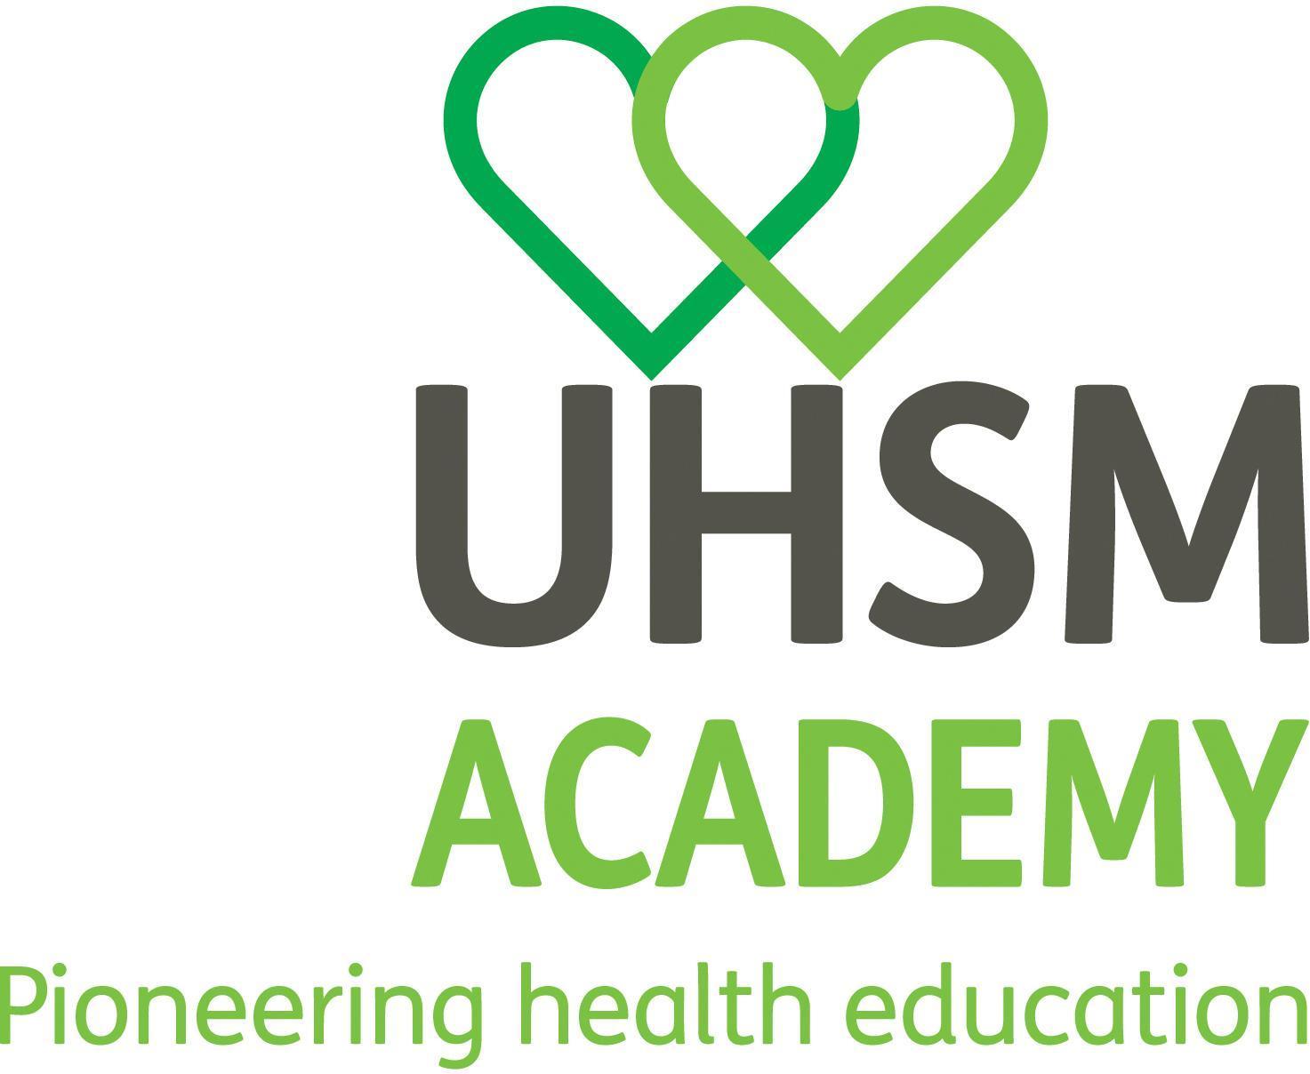

SAGE & THYME® UK 2014 - 4th Annual Conference
Wednesday 19 November 2014, 9:30am - 4:15pm
Education and Research Centre, Wythenshawe Hospital, Manchester

Lecture Theatre 1
Time | Chair – Cameron Langlands, SAGE & THYME Team
9:30-9:50 | Registration
9:50-9:55 | Welcome – Felicity Goodey, Chair of UHSM
9:55-10:25 | SAGE & THYME update - Mike Connolly, SAGE & THYME Team
10:25-10:50 | From early adoption to large scale roll-out across the PallE8 network - Katherine Hopkins, Royal Free London NHS Foundation Trust
10:50-11:10 | Boots pharmacists working with patients – David Walker, Boots UK Ltd
11:10-11:30 | BREAK
11:30-11:45 | Incorporating SAGE & THYME in mandatory training – Joanne Lane, Aneurin Bevan University Health Board
11:45-12:00 | Princess Alice education centre experience – Gill Thomas, Princess Alice Hospice
12:00-12:30 | Advance care planning: current climate and SAGE & THYME ACP workshop evaluation – Mike Connolly and Joanne Thomas, SAGE & THYME Team
12:30-13:30 | LUNCH and NETWORKING
Parallel sessions: | A – Lecture Theatre 2 | B – Seminar Room 4
1st session:  13:30-14:30 | Getting the group work right – Elaine Bramhall and Sheona Ramsbottom, SAGE & THYME Team | Keeping on top of the evidence – Mike Connolly, SAGE & THYME Team
14:30-14:55 | BREAK
Parallel sessions: | A – Lecture Theatre 2 | B – Seminar Room 4
2nd session:  14:55-15:55 | Finding out what patients think – how do we do it?  Dr Debra de Silva, Evidence Centre | Using SAGE & THYME with patients and relatives: sharing stories – Mike Connolly, SAGE & THYME Team
15:55-16:00 | Return to Lecture Theatre 1
Lecture Theatre 1
16:00-16:15 | Q&A session, evaluation and close

